# Login pages

Gadget Galaxy

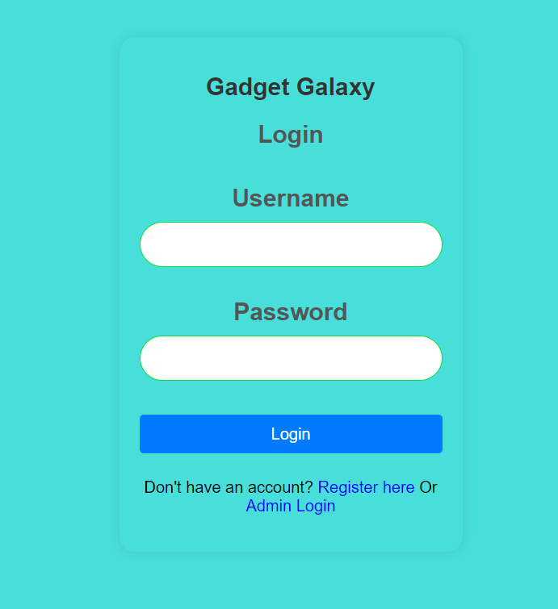 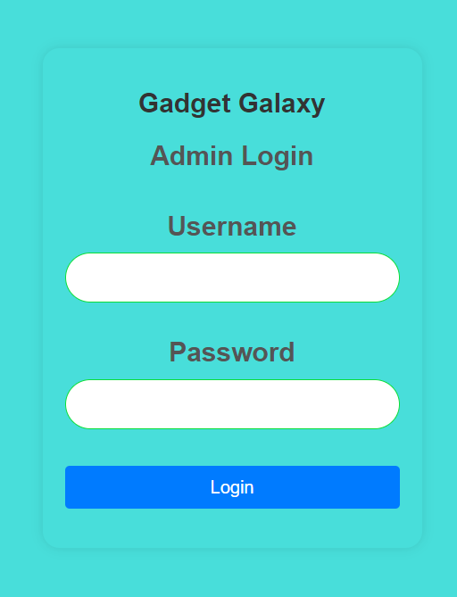

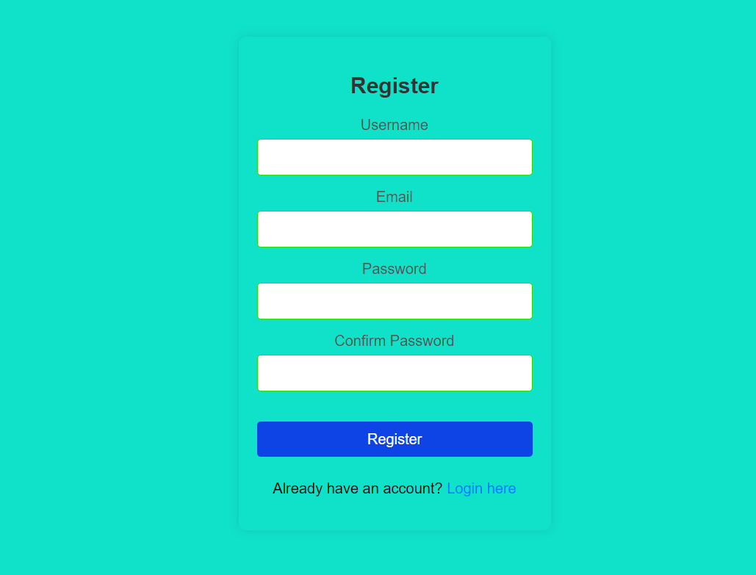

Home pages

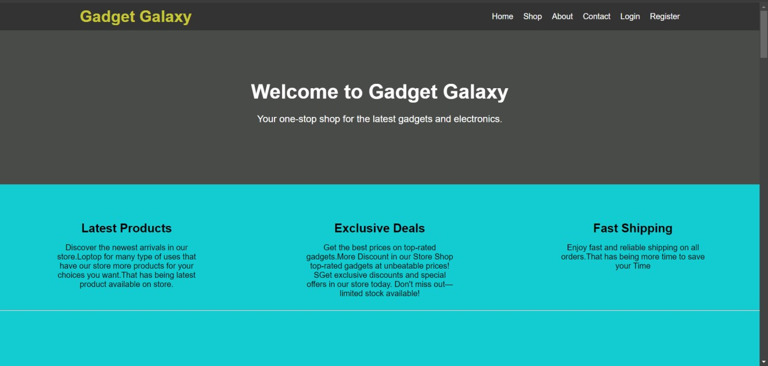

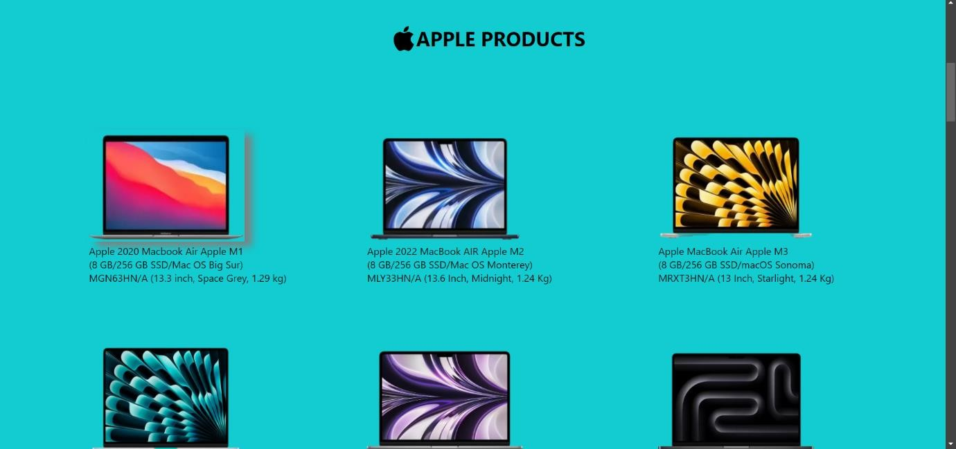

Manage Products

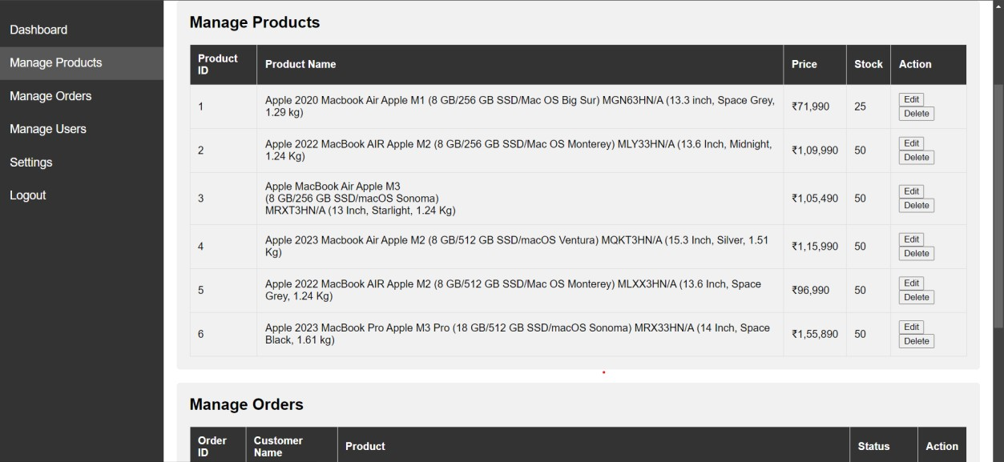

Manage Orders

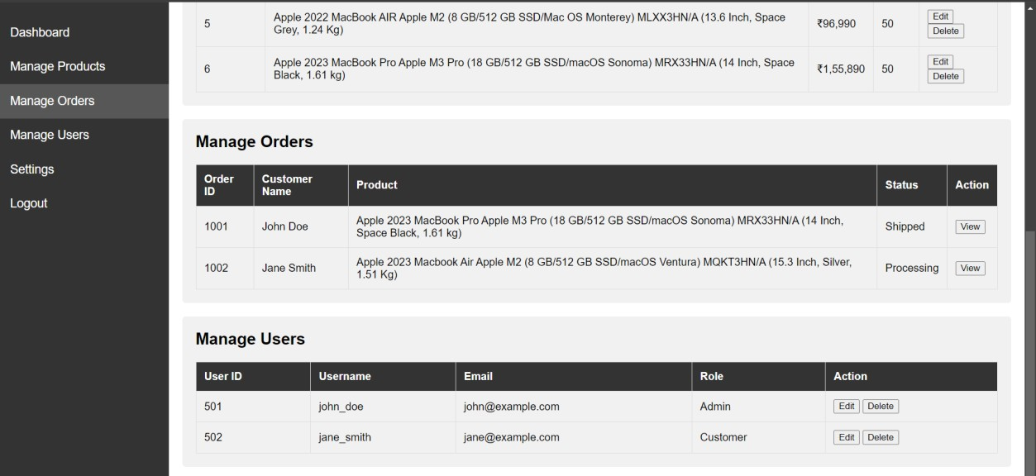

Order Page

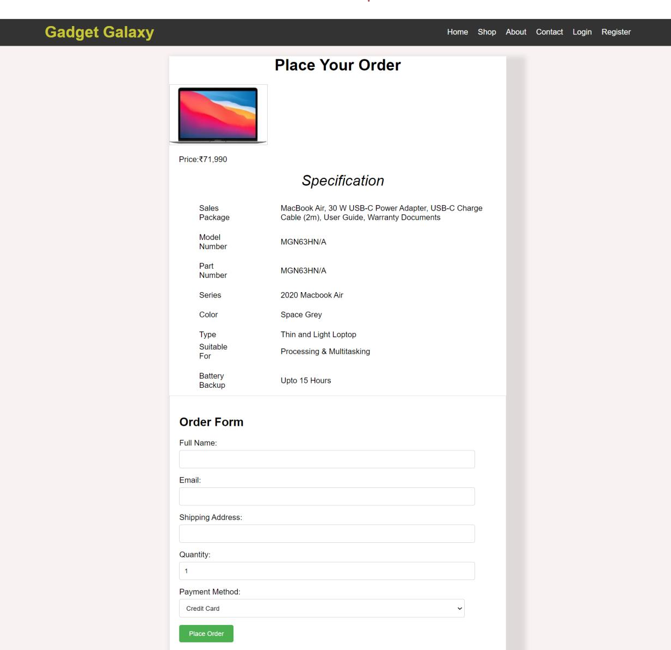

Order Confirmation page

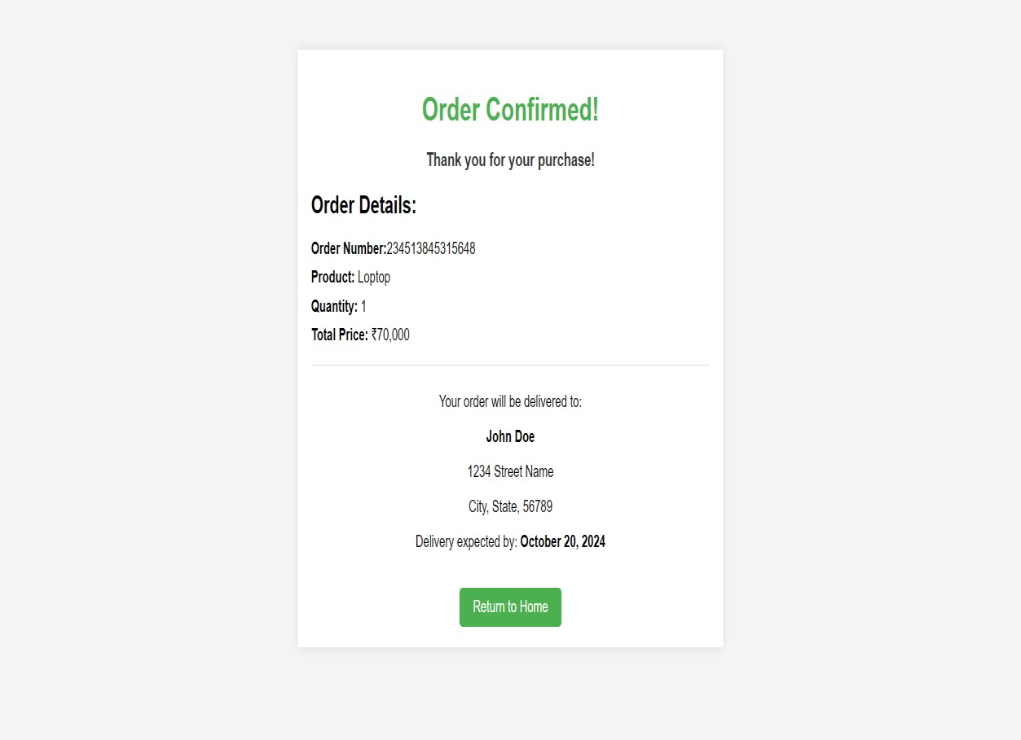

**Code:**

# Login Page:

<!DOCTYPE html>

<html lang="en">

<head>

<meta charset="UTF-8">

<meta name="viewport" content="width=device-width, initial-scale=1.0">

<title>Gadget Galaxy - Login</title>

<link rel="stylesheet" href="stylelogin.css">

</head>

<body>

<div class="login-container">

<div class="text">

<h1>Gadget Galaxy</h1>

<h2>Login</h2>

<form id="login-container" action="Home.html" method="get">

<h1><label>Username</label></h1>

<input type="text" id="Username" name="Username" required >

<h1><label>Password</label></h1>

<input type="password" id="Password" name="Password" required><br>

<input type="submit" class="but" value="Login">

</form>

<p>Don't have an account? <a href="Register.html">Register here</a> Or <a href="Admin Login.html">Admin Login</a></p>

</div>

</div>

</body>

</html> body {

background-image: url(''); background-repeat: no-repeat; background-size: cover;

font-family: Arial, sans-serif; background-color: #10d5cfc3; display: flex;

justify-content: center;

align-items: center; height: 100vh; margin: 0;

}

.login-container { background-color: #fff; padding: 20px;

border-radius: 15px;

box-shadow: 0 0 10px rgba(0, 0, 0, 0.1); width: 300px;

text-align: center; background:transparent

}

h1 {

margin-bottom: 10px; color: #333;

font-size: 24px;

}

h2 {

margin-bottom: 20px; color: #555;

}

form {

display: flex;

flex-direction: column;

}

label {

margin-bottom: 5px; color: #555;

}

input{

padding: 10px; margin-bottom: 15px;

border: 1px solid #0ade38;

border-radius: 40px; font-size: 20px;

}

.login{

text-decoration: none;

}

.but {

padding: 10px;

background-color: #007bff; color: white;

border: none; border-radius: 4px; cursor: pointer; font-size: 16px;

}

.but:hover {

background-color: #57f900;

}

p {

margin-top: 10px;

}

a {

color: blue;

text-decoration: none;

}

Register Page:

<!DOCTYPE html>

<html lang="en">

<head>

<meta charset="UTF-8">

<meta name="viewport" content="width=device-width, initial-scale=1.0">

<title>Register Page</title>

<link rel="stylesheet" href="styleregister.css">

</head>

<body>

<div class="register-container">

<h2>Register</h2>

<form action="Login.html" method="get">

<label for="username">Username</label>

<input type="text" id="username" name="username" required>

<label for="email">Email</label>

<input type="email" id="email" name="email" required>

<label for="password">Password</label>

<input type="password" id="password" name="password" required>

<label for="confirm-password">Confirm Password</label>

<input type="password" id="confirm-password" name="confirm-password" required>

<br>

<input type="submit" class="but" value="Register">

</form>

<p>Already have an account? <a href="Login.html">Login here</a></p>

</div>

</body>

</html> body {

font-family: Arial, sans-serif; background-color:#10e1c9; display: flex;

justify-content: center; align-items: center; height: 100vh; margin: 0;

}

.register-container { background-color: #fff; padding: 20px;

border-radius: 8px;

box-shadow: 0 0 10px rgba(0, 0, 0, 0.1); width: 300px;

text-align: center; background: transparent;

}

h2 {

margin-bottom: 20px; color: #333;

}

form {

display: flex;

flex-direction: column;

}

label {

margin-bottom: 5px; color: #555;

}

input {

padding: 10px; margin-bottom: 15px;

border: 1px solid #27df06; border-radius: 4px;

font-size: 16px;

}

.but {

padding: 10px;

background-color: #0e44e6; color: white;

border: none; border-radius: 4px; cursor: pointer; font-size: 16px;

}

.but:hover {

background-color: #46ed04;

}

p {

margin-top: 10px;

}

a {

color: #007bff;

text-decoration: none;

}

a:hover {

text-decoration: underline;

}

# Admin Login

<!DOCTYPE html>

<html lang="en">

<head>

<meta charset="UTF-8">

<meta name="viewport" content="width=device-width, initial-scale=1.0">

<title>Gadget Galaxy - Login</title>

<style>

body {

background-repeat: no-repeat; background-size: cover;

font-family: Arial, sans-serif; background-color: #10d5cfc3; display: flex;

justify-content: center; align-items: center; height: 100vh; margin: 0;

}

.login-container { background-color: #fff; padding: 20px;

border-radius: 15px;

box-shadow: 0 0 10px rgba(0, 0, 0, 0.1); width: 300px;

text-align: center; background:transparent

}

h1 {

margin-bottom: 10px; color: #333;

font-size: 24px;

}

h2 {

margin-bottom: 20px; color: #555;

}

form {

display: flex;

flex-direction: column;

}

label {

margin-bottom: 5px; color: #555;

}

input{

padding: 10px; margin-bottom: 15px;

border: 1px solid #0ade38; border-radius: 40px;

font-size: 20px;

}

.login{

text-decoration: none;

}

.but {

padding: 10px;

background-color: #007bff; color: white;

border: none; border-radius: 4px; cursor: pointer; font-size: 16px;

}

.but:hover {

background-color: #57f900;

}

</style>

</head>

<body>

<div class="login-container">

<div class="text">

<h1>Gadget Galaxy</h1>

<h2>Admin Login</h2>

<form id="login-container" action="Admin.html" method="get">

<h1><label>Username</label></h1>

<input type="text" id="Username" name="Username" required >

<h1><label>Password</label></h1>

<input type="password" id="Password" name="Password" required><br>

<input type="submit" class="but" value="Login">

</form>

</div>

</div>

</body></html>

# Admin Panel

<!DOCTYPE html>

<html lang="en">

<head>

<meta charset="UTF-8">

<meta name="viewport" content="width=device-width, initial-scale=1.0">

<title>Admin Panel - Gadget Galaxy</title>

<style>

body {

font-family: Arial, sans-serif; margin: 0;

padding: 0;

}

.sidebar { height: 100%; width: 250px;

position: fixed; top: 0;

left: 0;

background-color: #333; padding-top: 20px;

}

.sidebar a { padding: 15px;

text-decoration: none; font-size: 18px; color: white;

display: block;

}

.sidebar a:hover {

background-color: #575757;

}

.main-content { margin-left: 250px; padding: 20px;

}

.main-content h1 { font-size: 24px; color: #333;

}

.card {

background-color: #f1f1f1; padding: 20px;

margin-bottom: 20px; border-radius: 5px;

}

.card h2 { margin-top: 0;

}

table {

width: 100%;

border-collapse: collapse;

}

table, th, td {

border: 1px solid #ddd;

}

th, td {

padding: 12px; text-align: left;

}

th {

background-color: #333; color: white;

}

</style>

</head>

<body>

<div class="sidebar">

<a href="#dashboard">Dashboard</a>

<a href="#products">Manage Products</a>

<a href="#orders">Manage Orders</a>

<a href="#users">Manage Users</a>

<a href="#settings">Settings</a>

<a href="Login.html">Logout</a>

</div>

<div class="main-content">

<h1>Welcome to Gadget Galaxy Admin Panel</h1>

<div class="card" id="dashboard">

<h2>Dashboard</h2>

<p>Overview of sales, orders, and site traffic</p>

</div>

<div class="card" id="products">

<h2>Manage Products</h2>

<table>

<thead>

<tr>

<th>Product ID</th>

<th>Product Name</th>

<th>Price</th>

<th>Stock</th>

<th>Action</th>

</tr>

</thead>

<tbody>

<tr>

<td>1</td>

<td>Apple 2020 Macbook Air Apple M1 (8 GB/256 GB SSD/Mac OS Big Sur)

MGN63HN/A (13.3 inch, Space Grey, 1.29 kg)</td>

<td>₹71,990</td>

<td>25</td>

<td><button>Edit</button> <button>Delete</button></td>

</tr>

<tr>

<td>2</td>

<td>Apple 2022 MacBook AIR Apple M2 (8 GB/256 GB SSD/Mac OS Monterey)

MLY33HN/A (13.6 Inch, Midnight, 1.24 Kg)</td>

<td>₹1,09,990</td>

<td>50</td>

<td><button>Edit</button> <button>Delete</button></td>

</tr>

<tr>

<td>3</td>

<td>Apple MacBook Air Apple M3<br>

(8 GB/256 GB SSD/macOS Sonoma) <br> MRXT3HN/A (13 Inch, Starlight, 1.24 Kg)</td>

<td>₹1,05,490</td>

<td>50</td>

<td><button>Edit</button> <button>Delete</button></td>

</tr>

<tr>

<td>4</td>

<td>Apple 2023 Macbook Air Apple M2

(8 GB/512 GB SSD/macOS Ventura) MQKT3HN/A (15.3

Inch, Silver, 1.51 Kg)</td>

<td>₹1,15,990</td>

<td>50</td>

<td><button>Edit</button> <button>Delete</button></td>

</tr>

<tr>

<td>5</td>

<td>Apple 2022 MacBook AIR Apple M2

(8 GB/512 GB SSD/Mac OS Monterey) MLXX3HN/A (13.6

Inch, Space Grey, 1.24 Kg)</td>

<td>₹96,990</td>

<td>50</td>

<td><button>Edit</button> <button>Delete</button></td>

</tr>

<tr>

<td>6</td>

<td>Apple 2023 MacBook Pro Apple M3 Pro

(18 GB/512 GB SSD/macOS Sonoma) MRX33HN/A (14

Inch, Space Black, 1.61 kg)</td>

<td>₹1,55,890</td>

<td>50</td>

<td><button>Edit</button> <button>Delete</button></td>

</tr>

</tbody>

</table>

</div>

<div class="card" id="orders">

<h2>Manage Orders</h2>

<table>

<thead>

<tr>

<th>Order ID</th>

<th>Customer Name</th>

<th>Product</th>

<th>Status</th>

<th>Action</th>

</tr>

</thead>

<tbody>

<tr>

<td>1001</td>

<td>John Doe</td>

<td>Apple 2023 MacBook Pro Apple M3 Pro

(18 GB/512 GB SSD/macOS Sonoma) MRX33HN/A (14

Inch, Space Black, 1.61 kg)</td>

<td>Shipped</td>

<td><button>View</button></td>

</tr>

<tr>

<td>1002</td>

<td>Jane Smith</td>

<td>Apple 2023 Macbook Air Apple M2

(8 GB/512 GB SSD/macOS Ventura) MQKT3HN/A (15.3

Inch, Silver, 1.51 Kg)</td>

<td>Processing</td>

<td><button>View</button></td>

</tr>

</tbody>

</table>

</div>

<div class="card" id="users">

<h2>Manage Users</h2>

<table>

<thead>

<tr>

<th>User ID</th>

<th>Username</th>

<th>Email</th>

<th>Role</th>

<th>Action</th>

</tr>

</thead>

<tbody>

<tr>

<td>501</td>

<td>john_doe</td>

<td[>j](mailto:john@example.com)o[hn@example.com](mailto:john@example.com)</td>

<td>Admin</td>

<td><button>Edit</button> <button>Delete</button></td>

</tr>

<tr>

<td>502</td>

<td>jane_smith</td>

<td[>jane@exam](mailto:jane@example.com)p[le.com](mailto:jane@example.com)</td>

<td>Customer</td>

<td><button>Edit</button> <button>Delete</button></td>

</tr>

</tbody>

</table>

</div>

</div>

</body>

</html>

# Home Page

<!DOCTYPE html>

<html lang="en">

<head>

<meta charset="UTF-8">

<meta name="viewport" content="width=device-width, initial-scale=1.0">

<title>Gadget Galaxy - Home</title>

<link rel="stylesheet" href="stylehome.css">

</head>

<body>

<header>

<div class="container">

<h1>Gadget Galaxy</h1>

<nav>

<ul>

<li><a href="Home.html">Home</a></li>

<li><a href="All product.html">Shop</a></li>

<li><a href="#about">About</a></li>

<li><a href="#about">Contact</a></li>

<li><a href="Login.html">Login</a></li>

<li><a href="Register.html">Register</a></li>

</ul>

</nav>

</div>

</header>

<section class="hero">

<div class="container">

<h2>Welcome to Gadget Galaxy</h2>

<p>Your one-stop shop for the latest gadgets and electronics.</p>

</div>

</section>

<section class="features">

<div class="container">

<div class="feature">

<h3>Latest Products</h3>

<p>Discover the newest arrivals in our store.Loptop for many type of uses that have our store

more products for your choices you want.That has being latest product available on store.

</p>

</div>

<div class="feature">

<h3>Exclusive Deals</h3>

<p>Get the best prices on top-rated gadgets.More Discount in our Store Shop top-rated gadgets at unbeatable prices!

SGet exclusive discounts and special offers in our store today. Don't miss out—limited stock available!</p>

</div>

<div class="feature">

<h3>Fast Shipping</h3>

<p>Enjoy fast and reliable shipping on all orders.That has being more time to save your Time </p>

</div>

</div>

<hr>

<div>

<table align="center">

<th colspan="5">

<center><h1 style="font-size: xx-large;"><sub><img src="apple.png" height="40px" width="40px"></sub>APPLE PRODUCTS</h1></center>

</th>

<tr>

<td><img src="M1.png" class="lop" height=180px width=250px><br>

<a href="Order M1.html">Apple 2020 Macbook Air Apple

M1<br>

(8 GB/256 GB SSD/Mac OS Big Sur)<br> MGN63HN/A (13.3 inch, Space Grey, 1.29 kg)</a>

</td>

<td>

<img src="M2.png"

class="lop" height=180px width=250px><br>

<a href="Order M2.html">Apple 2022 MacBook AIR Apple M2

<br>(8 GB/256 GB SSD/Mac OS Monterey)<br> MLY33HN/A (13.6 Inch, Midnight, 1.24 Kg)</a>

</td>

<td>

<img src="M3.png"

class="lop" height=180px width=250px><br>

<a href="Order M3.html">Apple MacBook Air Apple M3<br> (8 GB/256 GB SSD/macOS Sonoma) <br>

MRXT3HN/A (13 Inch, Starlight, 1.24 Kg)</a>

</td>

</tr>

<tr>

<td><img src="M2.1.png" class="lop" height=180px width=250px><br>

<a href="Order M2.1.html">Apple 2023 Macbook Air Apple

M2<br>

(8 GB/512 GB SSD/macOS Ventura) MQKT3HN/A (15.3

Inch, Silver, 1.51 Kg)</a>

</td>

<td><img src="M2.2.png" class="lop" height=180px width=250px><br>

<a href="Order M2.2.html">Apple 2022 MacBook AIR Apple

M2<br>

(8 GB/512 GB SSD/Mac OS Monterey) MLXX3HN/A (13.6

Inch, Space Grey, 1.24 Kg)</a>

</td>

<td><img src="M3.1.png" class="lop" height=180px width=250px><br>

<a href="Order M3.1.html">Apple 2023 MacBook Pro Apple

M3 Pro<br>

(18 GB/512 GB SSD/macOS Sonoma) MRX33HN/A (14

Inch, Space Black, 1.61 kg)</a>

</td>

</tr>

</table>

<hr>

<table align="center">

<th colspan="5">

<center><h1 style="font-size: xx-large;"><sub><img src="Asus.png" height="40px" width="180px"></sub>ASUS PRODUCTS</h1></center>

</th>

<tr>

<td><img src="As.1.png" class="lop" width="250" height="250"><br>

<a href="Order As.1.html">ASUS TUF Gaming F17 - AI Powered Gaming Intel Core i5 11th Gen 11400H - <br>

(16 GB/512 GB SSD/Windows 11 Home/4 GB Graphics/NVIDIA GeForce RTX 2050/70 W) <br>

FX706HF-NY040W Gaming Laptop <br>(17.3 Inch, Graphite Black, 2.60 kg)</a>

</td>

><br>

<td><img src="As.2.png" class="lop" width="280" height="250"

<a href="Order As.2.html">ASUS TUF Gaming F15 Intel Core i5

12th Gen 12500H<br>

(16 GB/512 GB SSD/Windows 11 Home/4 GB Graphics/NVIDIA GeForce RTX 3050) <br>

FX507ZC4-HN116W Gaming Laptop <br> (15.6 Inch, Mecha Gray, 2.20 Kg)</a>

</td>

<td><img src="As.3.png" class="lop" width="250" height="210"><br>

<a href="Order As.3.html">ASUS TUF Gaming F15 Intel Core i7 11th Gen 11800H<br>

(16 GB/1 TB SSD/Windows 10 Home/4 GB Graphics/NVIDIA GeForce RTX 3050/144 Hz)<br>

FX506HCB-HN225T Gaming Laptop <br> (15.6 inch, Graphite Black, 2.30 kg)</a>

</td>

</tr>

<tr>

<td><img src="As.4.png" class="lop" width="250" height="210"><br>

<a href="Order As.4.html">ASUS TUF Gaming F15 Intel Core i5 10th Gen 10300H<br>

(8 GB/512 GB SSD/Windows 10 Home/4 GB Graphics/NVIDIA GeForce GTX 1650/144 Hz/50 W) <br>

FX506LH-HN258T Gaming Laptop (15.6 Inch, Black Plastic,

2.3 KG)</a>

</td>

<td><img src="As.5.png" class="lop" width="250" height="210"><br>

<a href="Order As.5.html">ASUS TUF Gaming A15 (2024) AMD Ryzen 9 Octa Core 8945H<br>

(16 GB/1 TB SSD/Windows 11 Home/8 GB Graphics/NVIDIA GeForce RTX 4070) FA507UI-LP066WS Gaming Laptop <br>

(15.6 Inch, Mecha Gray, 2.2 Kg)</a>

</td>

<td><img src="As.6.png" class="lop" width="250" height="210"><br>

<a href="Order As.6.html">ASUS TUF Gaming F15 (2024) Intel Core i7 12th Gen 12700H <br>

(16 GB/1 TB SSD/Windows 11 Home/6 GB Graphics/NVIDIA GeForce RTX 3060/165 Hz)<br>

FX577ZM-HQ067WS Gaming Laptop (15.6 inch, Jaeger Gray,

2.20 kg, With MS Office)</a>

</td>

</tr>

</table>

</div>

<hr>

<table align="center">

<th colspan="5">

<center><h1 style="font-size: xx-large;"><sub><img src="HP.png" height="45px" width="40px"></sub> HP PRODUCTS</h1></center>

</th>

<tr>

<td><img src="Hp.1.png" class="lop" width="250" height="210"><br>

<a href="Order Hp.1.html">HP Laptop AMD Ryzen 3 Quad Core 5300U<br>

(8 GB/512 GB SSD/Windows 11 Home) 15s- eq2212AU Thin and Light Laptop <br>

(15.6 Inch, Natural Silver, 1.69 Kg, With MS Office)</a>

</td>

<td>

<img src="Hp.2.png" class="lop" width="250" height="210"><br>

<a href="Order Hp.2.html"> 360 Intel Celeron Quad Core

N4120<br>

Kg)</a>

(4 GB/64 GB EMMC Storage/Chrome OS) <br>

14a-ca0504TU Chromebook Laptop (14 Inch, Forest Teal, 1.49

</td>

<td>

<img src="Hp.3.png" class="lop" width="250" height="210"><br>

<a href="Order Hp.3.html">HP AMD Ryzen 5 Hexa Core

5500U<br>

(8 GB/512 GB SSD/Windows 11 Home) 15s- eq2144au Thin

and Light Laptop<br>

(15.6 inch, Natural Silver, 1.69 kg, With MS Office)</a>

</td>

</tr>

<tr>

<td>

<img src="Hp.4.png" class="lop" width="270" height="210"><br>

<a href="Order Hp.4.html">HP 250 G9 Intel Core i3 12th Gen Intel Core i3 1215U<br>

(8 GB/512 GB SSD/Windows 11 Home) 250 G9 Business

Laptop <br>

</td>

<td>

(15.6 inch, Silver, 1.47 kg)</a>

><br>

<img src="Hp.5.png" class="lop" width="270" height="210"

<a href="Order Hp.5.html">HP 255 G9 AMD Ryzen 3 Dual Core

R3 3250<br>

Laptop <br>

(8 GB/512 GB SSD/Windows 11 Home) 255 G8 Business

(15.6 Inch, Black, 1.74 Kg)</a>

</td>

<td>

<img src="Hp.6.png" class="lop" width="270" height="210"><br>

<a href="Order Hp.6.html">HP 2023 Backlit Intel Core i5 12th Gen 1235U <br>

(8 GB/512 GB SSD/Windows 11 Home) 15s-fy5002TU Thin and Light Laptop<br>

(15.6 Inch, Natural Silver, 1.69 Kg, With MS Office)

</a>

</td>

</tr>

</table>

<hr>

<table align="center">

<th colspan="5">

<center><h1 style="font-size: xx-large;"><sub><img src="Dell.png" height="40px" width="40px"></sub>DELL PRODUCTS</h1></center>

</th>

<tr>

<td>

<img src="D.1.png" class="lop" height="170" width="270"><br>

<a href="Order D.1.html">DELL Inspiron 3520 Intel Core i3 12th Gen 1215U<br>

(8 GB/512 GB SSD/Windows 11 Home) <br>

New Inspiron 15 Laptop Thin and Light Laptop<br>

(15.6 Inch, Platinum Silver, 1.65 Kg, With MS Office)</a>

</td>

<td>

<img src="D.2.png" class="lop" height="190" width="270"><br>

<a href="Order D.2.html">DELL Inspiron 15 3520 Intel Core i5 12th Gen Core i5<br>

(16 GB/512 GB SSD/Windows 11 Home) Inspiron 3520

Laptop <br>

(15.6 inch, Platinum Silver, 1.65 kg, With MS Office)</a>

</td>

<td>

<img src="D.3.png" class="lop" height="180" width="270"><br>

<a href="Order D.3.html">DELL Inspiron Intel Core i7 13th Gen

1355U<br>

(16 GB/512 GB SSD/Windows 11 Home) <br>

Inspiron 3530 Thin and Light Laptop <br>

(15.6 inch, Platinum Silver, With MS Office)</a>

</td>

</tr>

<tr>

<td>

<img src="D.4.png" class="lop" height="180" width="270"><br>

<a href="Order D.4.html">DELL Inspiron 15 AMD Ryzen 5 Quad Core 5500u<br>

(8 GB/512 GB SSD/Windows 11 Home) Inspiron 3525 Thin and Light Laptop<br>

(15.6 inch, Platinum Silver, 1.8 Kg, With MS Office)</a>

</td>

<td>

<img src="D.5.png"class="lop" height="200" width="270"><br>

<a href="Order D.5.html">DELL Intel Core i5 13th Gen<br>

(16 GB/1 TB SSD/Windows 11 Home/6 GB Graphics/NVIDIA GeForce RTX 3050)<br>

G15-5530 Gaming Laptop (15.6 inch, Dark Shadow Gray, 2.81 kg, With MS Office)</a>

</td>

<td>

<img src="D.6.png" class="lop" height="200" width="270"><br>

<a href="Order D.6.html">DELL Intel Core i5 13th Gen

1334U<br>

(8 GB/512 GB SSD/Windows 11 Home) Inspiron 3530 Thin and

Light Laptop<br>

(15.6 inch, Carbon Black, 1.62 Kg, With MS Office)</a>

</td>

</tr>

</table>

<center><button onclick="location.href='All product.html'"><i>SHOW MORE...</i></button></center>

</section>

<footer style="background-color: #2d2020; padding: 20px; text-align: center;">

<div style="display: flex; justify-content: space-around; flex-wrap: wrap;">

<div style="flex: 1; min-width: 200px; margin: 10px;" id="about">

<h4>About Us</h4>

<p>We are committed to providing the best services and solutions to help you achieve your goals. Learn more about our journey, mission, and values.</p>

<a href="#" style="text-decoration: none; color: #007bff;">Learn More</a>

</div>

<div style="flex: 1; min-width: 200px; margin: 10px;">

<h4>Contact Us</h4>

<p>Have questions or want to get in touch? We'd love to hear from

you!</p>

<p>Email: <a href="mailto:Gadget Galaxy.com" style="text-

decoration: none; color: #007bff;">[infoGadgetGalaxy@gmail.com](mailto:infoGadgetGalaxy@gmail.com)</a></p>

<p>Phone: <a href="tel:+1234567890" style="text-decoration: none; color: #007bff;">+1 (234) 567-890</a></p>

</div>

</div>

<hr style="margin: 20px 0; border: none; border-top: 1px solid #eaeaea;"

/>

<p>&copy; 2024 Gadget Galaxy. All rights reserved.</p>

</footer>

</body>

</html> body {

font-family: Arial, sans-serif; margin: 0;

padding: 0;

background-color: #363835e6;

}

img.lop:hover{

box-shadow: 12px 8px 12px gray;

}

header {

background-color: #333; color: #e7e736d2;

padding: 10px 0;

}

a{

text-decoration: none; color: black;

}

a:hover{

color: #5ff900;

}

button{

background-color: #007bff; border-radius: 15px;

box-shadow: #007bff;

}

button:hover {

background-color: #00f9f1;

}

table{

border-spacing: 92px;

font-family: system-ui, -apple-system, BlinkMacSystemFont, 'Segoe UI', Roboto, Oxygen, Ubuntu, Cantarell, 'Open Sans', 'Helvetica Neue', sans-serif;

padding-left: 50px;

}

header .container { display: flex;

justify-content: space-between; align-items: center;

max-width: 1200px; margin: 0 auto;

padding: 0 20px;

}

header h1 { margin: 0;

header nav ul { list-style: none; margin: 0;

padding: 0; display: flex;

}

header nav ul li {header .container { display: flex;

justify-content: space-between; align-items: center;

max-width: 1200px; margin: 0 auto;

padding: 0 20px;

}

margin-left: 20px;

}

header nav ul li a { color: #fff;

text-decoration: none; transition: color 0.3s;

}

header nav ul li a:hover { color: #007bff;

}

.hero {

color: #fff;

text-align: center; padding: 100px 0;

}

.hero .container { max-width: 800px; margin: 0 auto;

.hero h2 {

margin: 0 0 20px; font-size: 2.5em;

}

.hero p {

margin: 0 0 20px; font-size: 1.2em;

}

.features {

background-color:rgba(0, 247, 255, 0.749);

padding: 50px 0; background-image: url('');

background-repeat: no-repeat;

}

.features .container { display: flex;

justify-content: space-around; text-align: center;

}

.features .feature { max-width: 300px;

}

.features h3 {

font-size: 1.5em; margin-bottom: 10px;

}

footer {

background-color: #333; color: #fff;

text-align: center; padding: 10px 0;

footer .container { max-width: 1200px; margin: 0 auto;

padding: 0 20px;

}

.about{

text-align: left; text-align: justify; font-size: 10px;

}